**Add Faculty:**

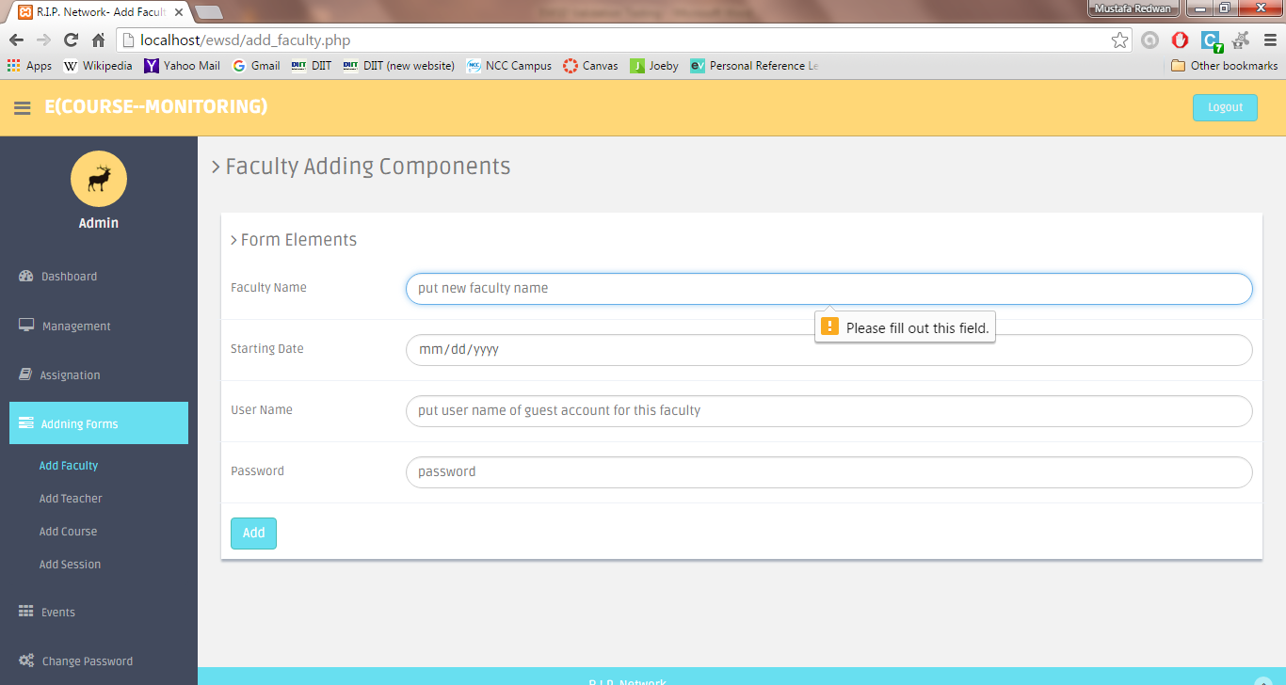

Fig 1: Faculty Name must be filled out

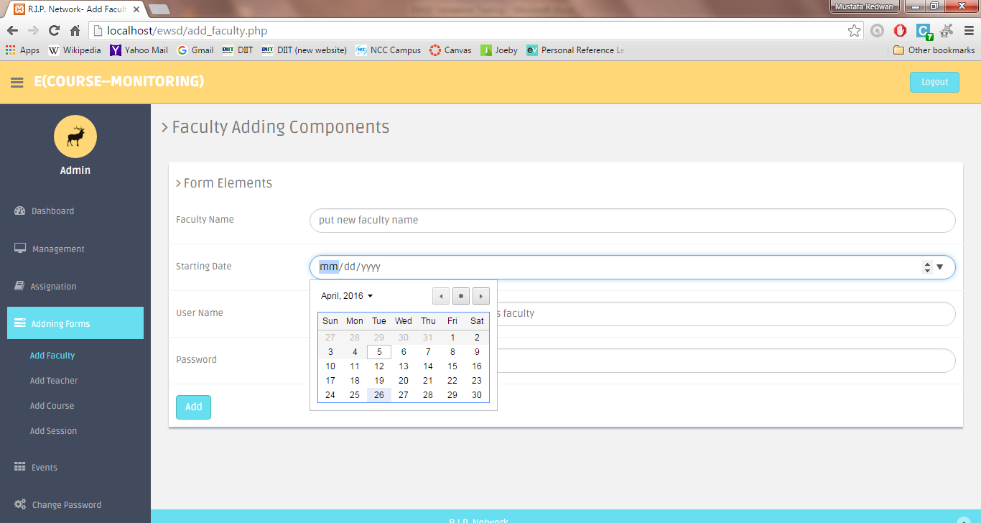

Fig 2: Starting Date – Today’s or later date must be chosen. No previous date is allowed

**Add teacher:**

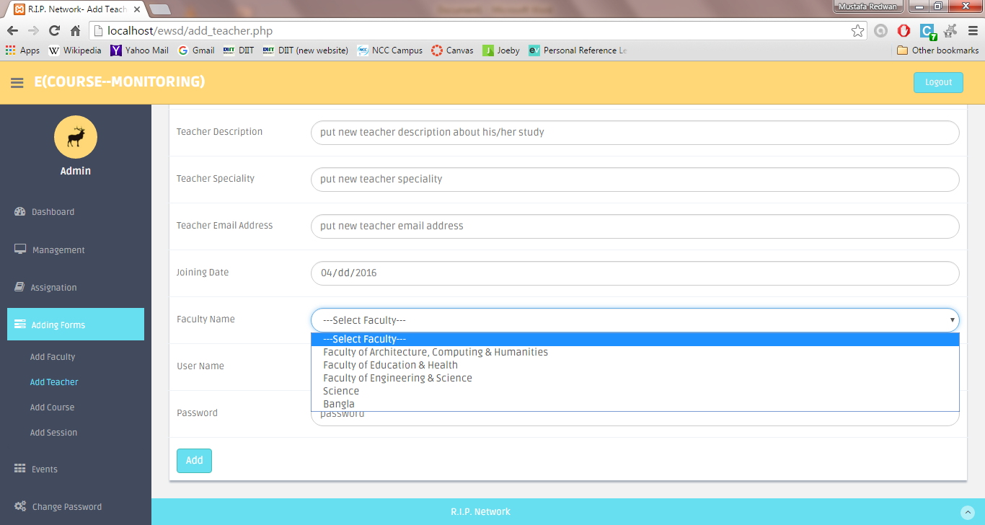

Fig 3: Faculty Name

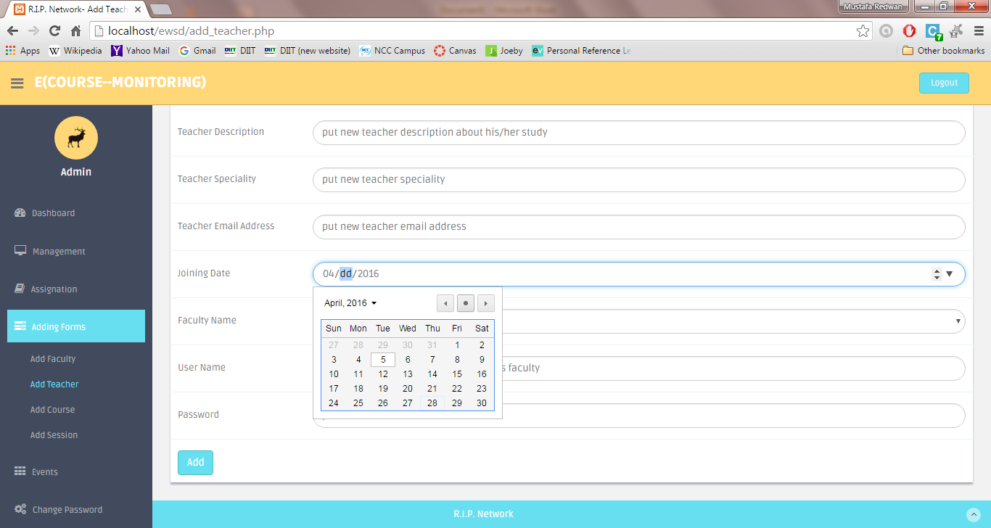

Fig 4: Date – We cannot select previous or later dates. Today’s date must be chosen.

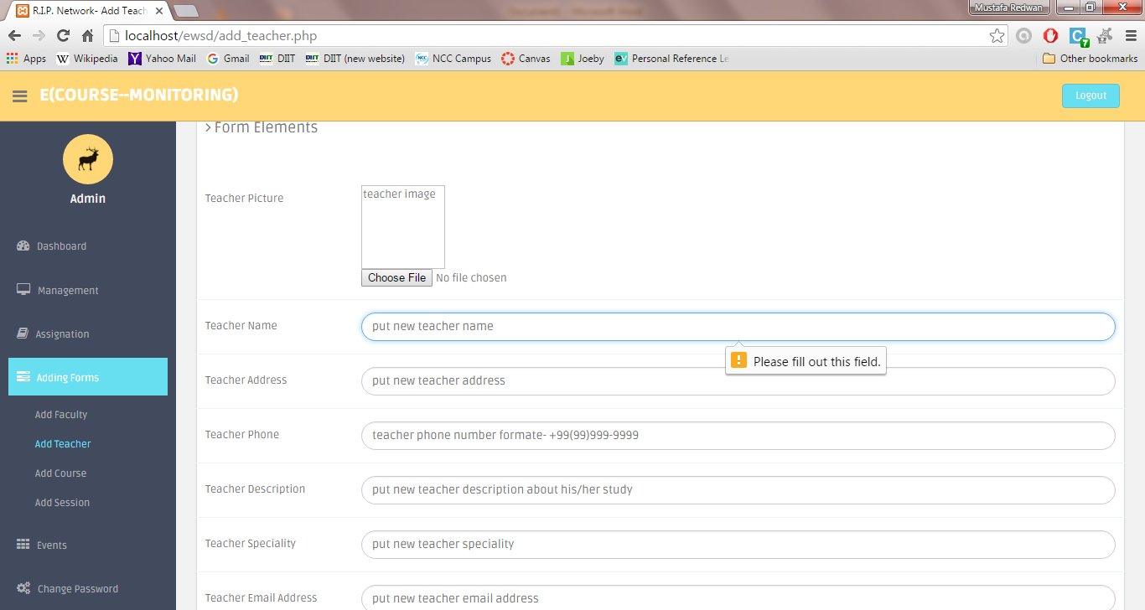

Fig 5: Teacher’s name field must be filled up

**Add Course:**

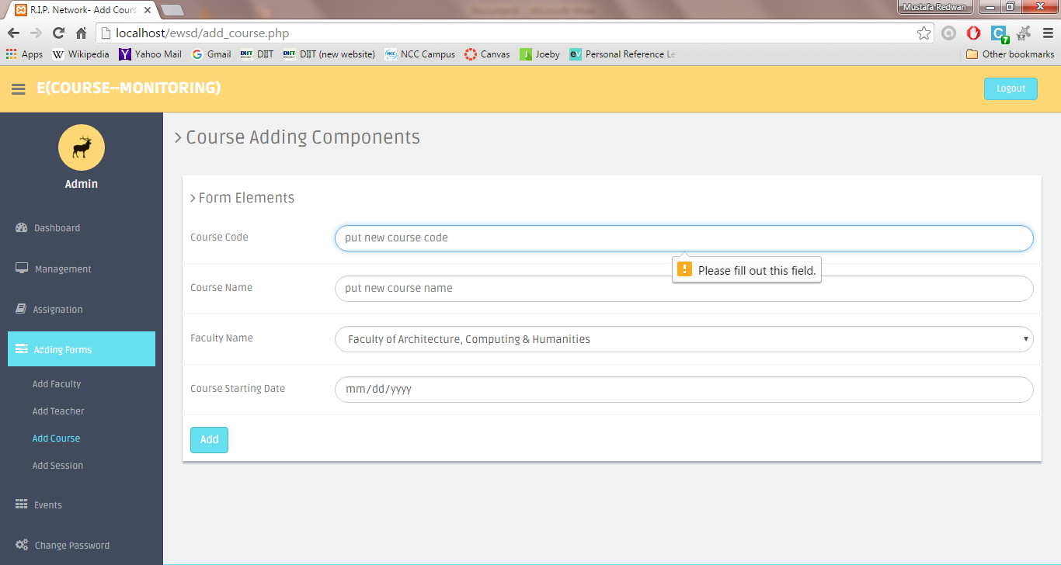

Fig 6: Course code must be filled up

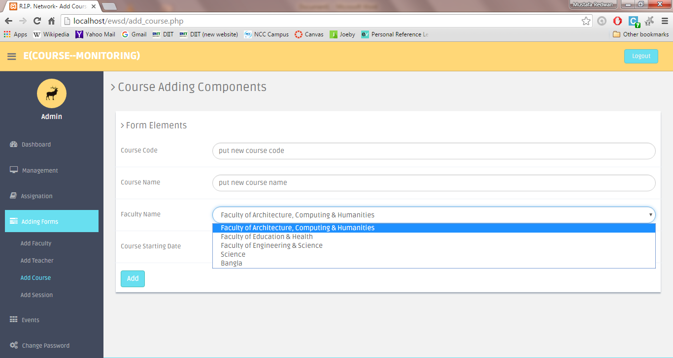

Fig 7: Faculty name must be selected from drop-down list

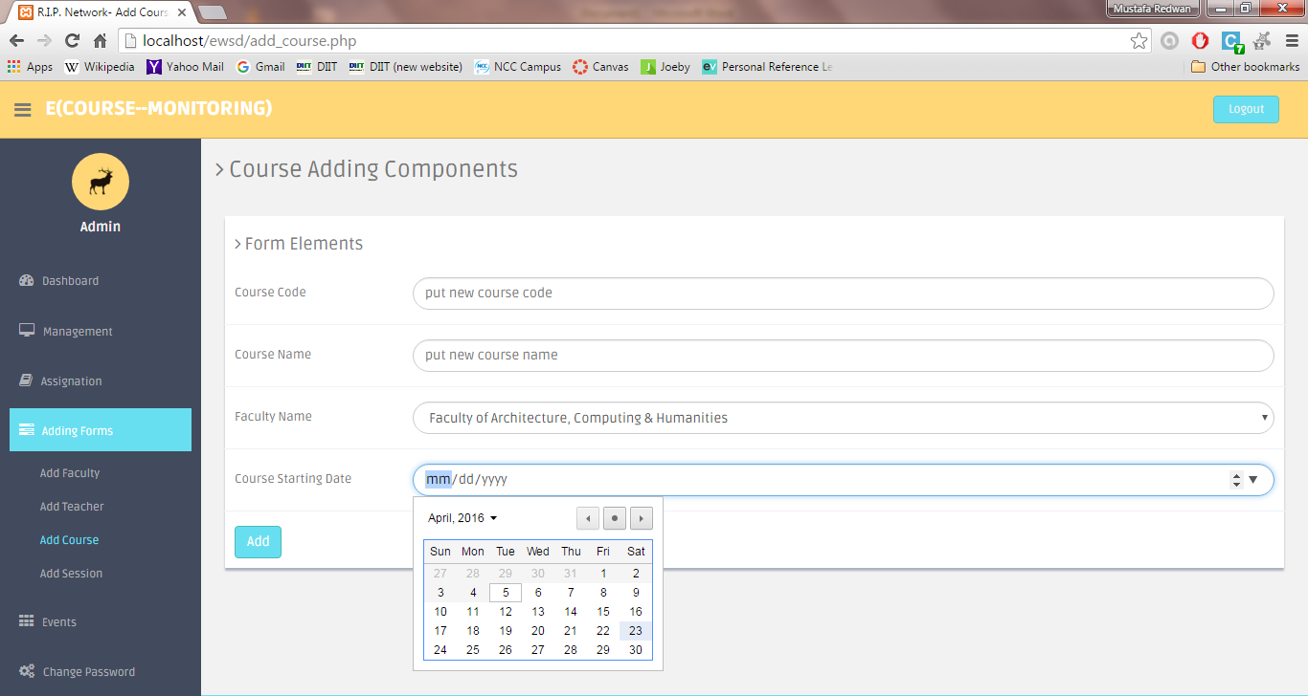

Fig 8: Today’s date or later must be selected. No previous date is allowed.

**Add Session:**

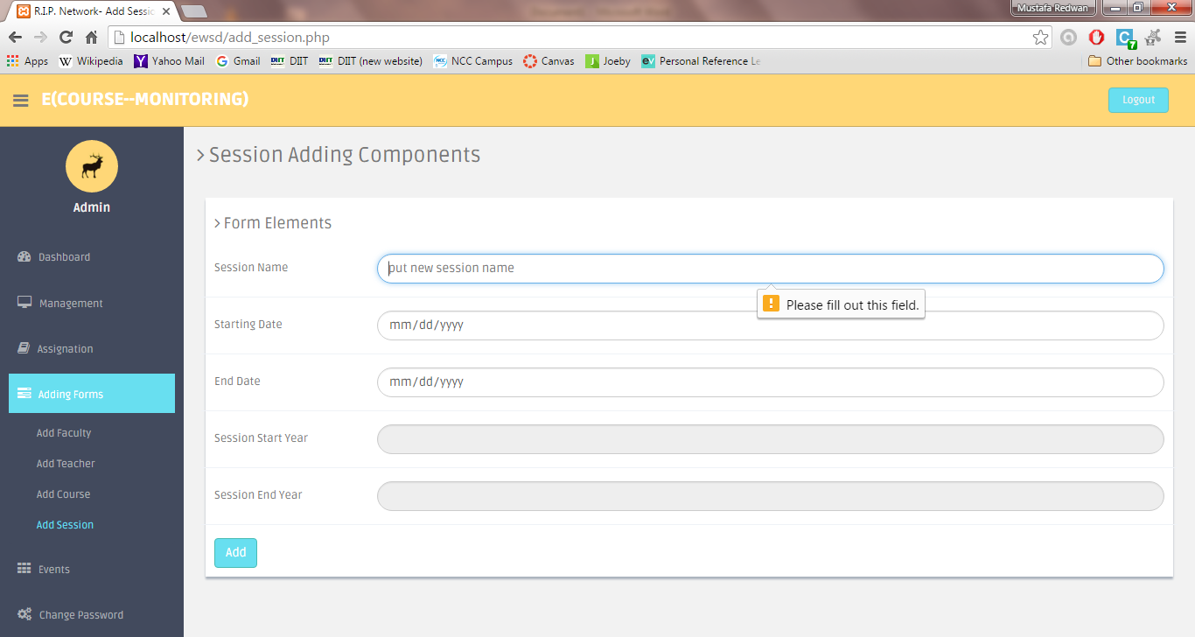

Fig 9: Name field must be filled up

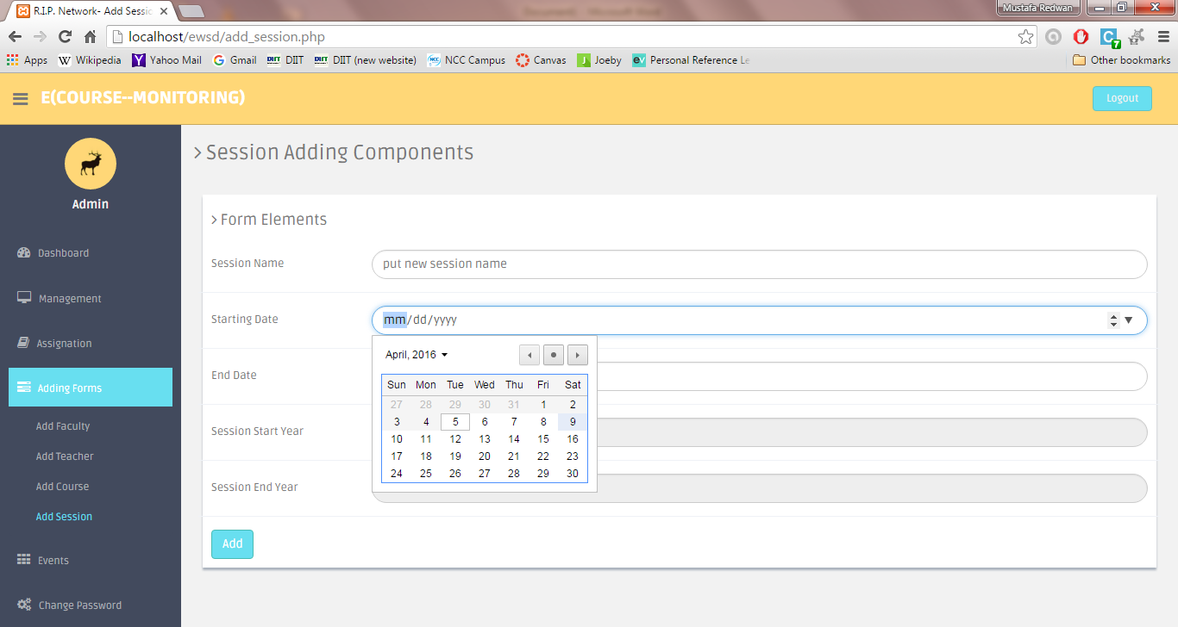

Fig 10: Today’s or later date must be selected for starting date. No previous date is allowed.

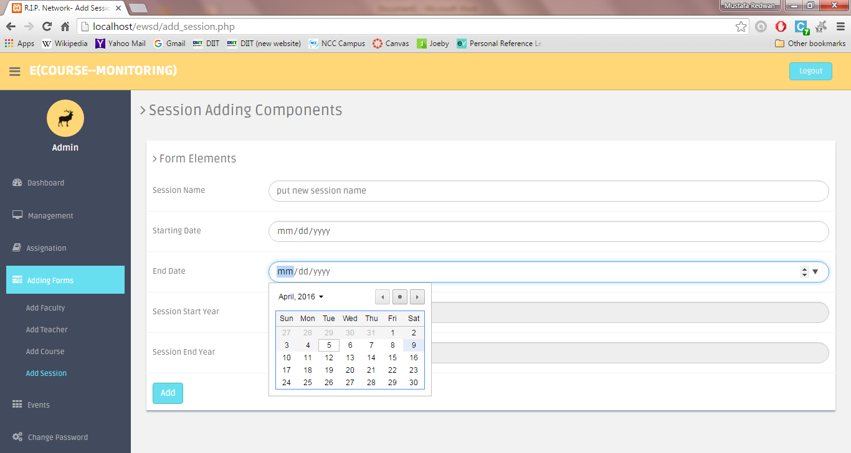

Fig 11: Today’s or later date must be selected for end date. No previous date is allowed.

**Add Event:**

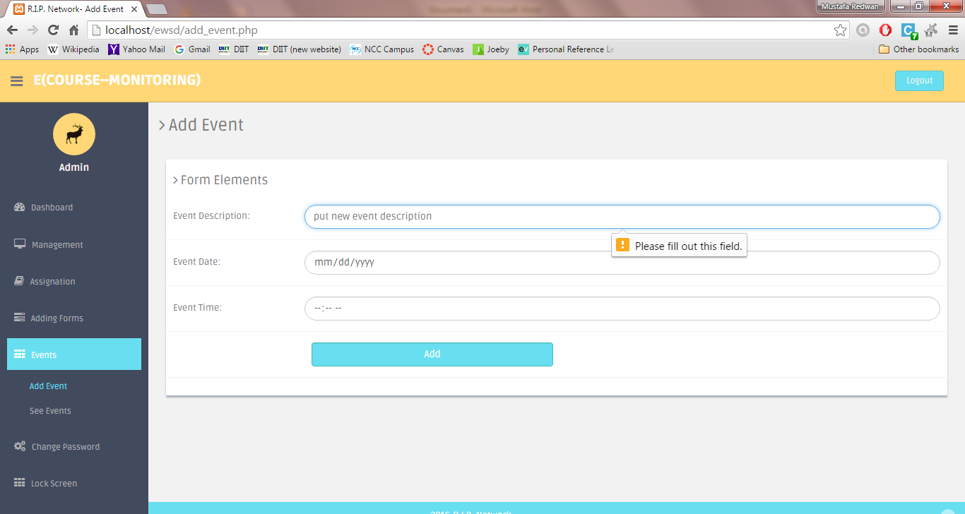

Fig 12: Description field must be filled up

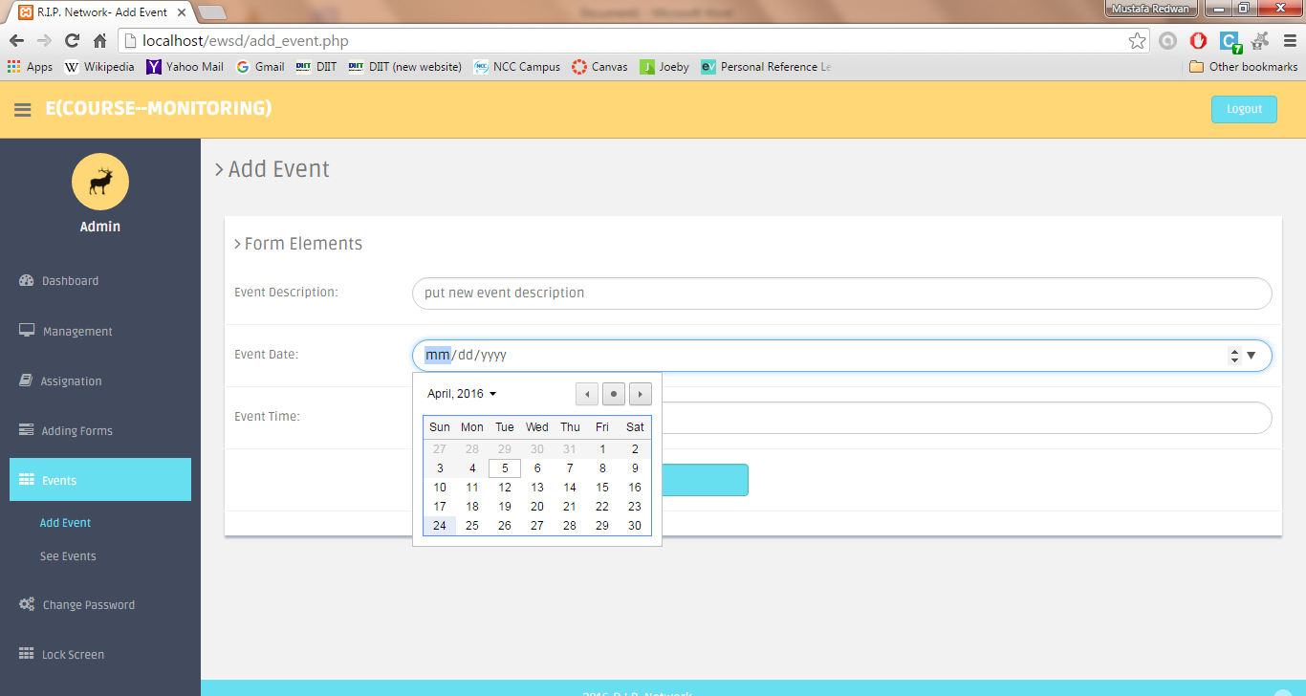

Fig 13: Today or later date must be selected. No previous date is allowed.

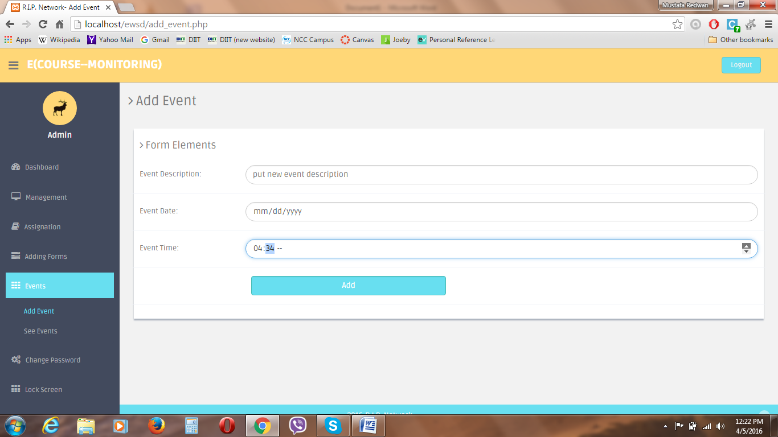

Fig 14: Time must be entered using integers only or as method shown in the screenshot above.

**Faculty Authority Assignation:**

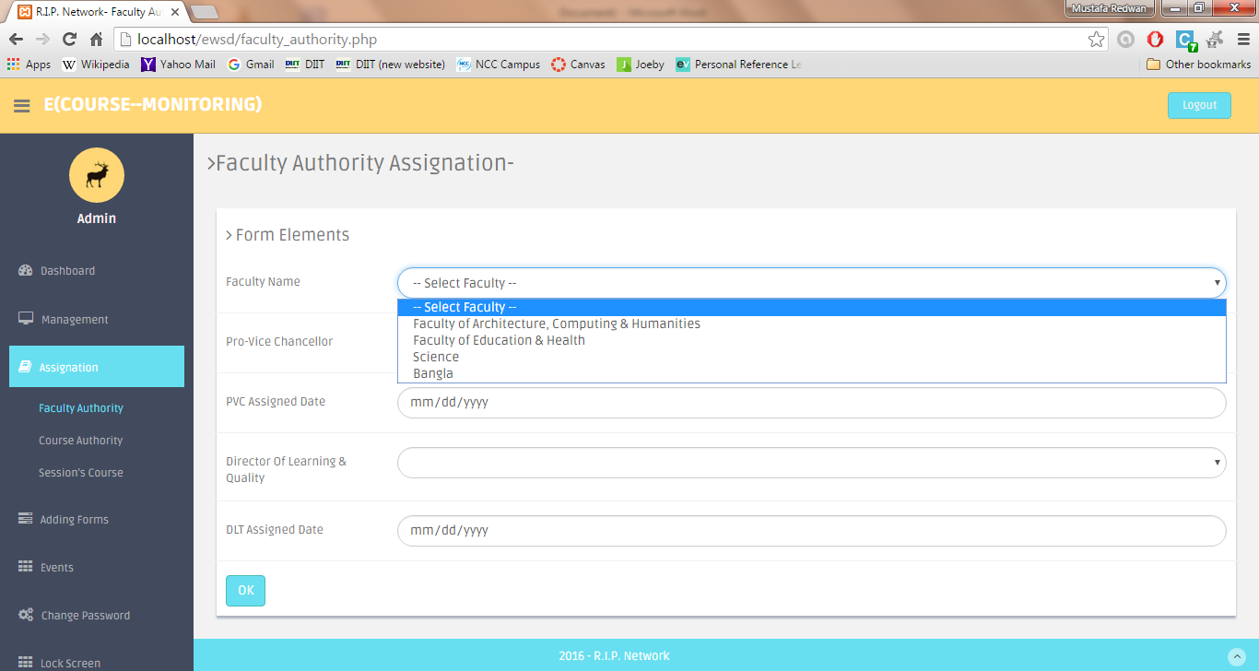

Fig 15: Faculty name selection

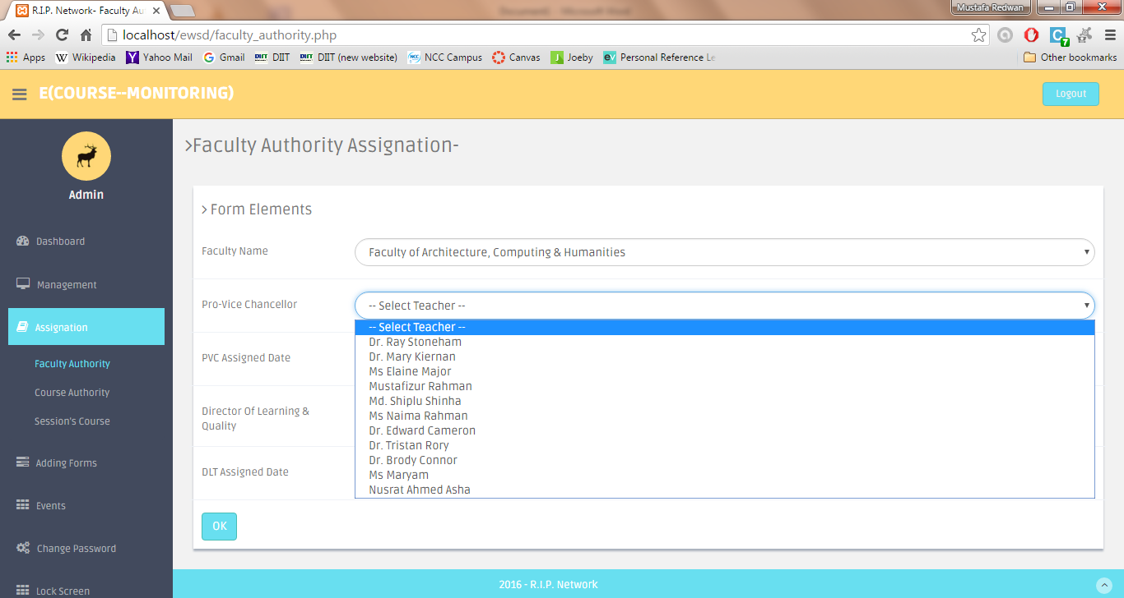

Fig 16: Pro-Vice Chancellor selection

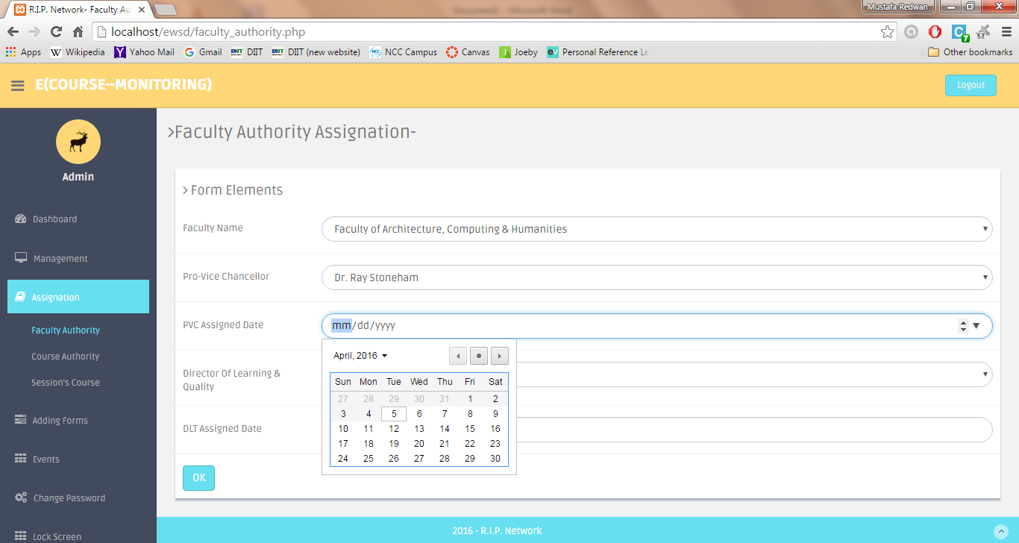

Fig 17: PVC Assigned date must be today’s date or later date. No previous date is allowed.

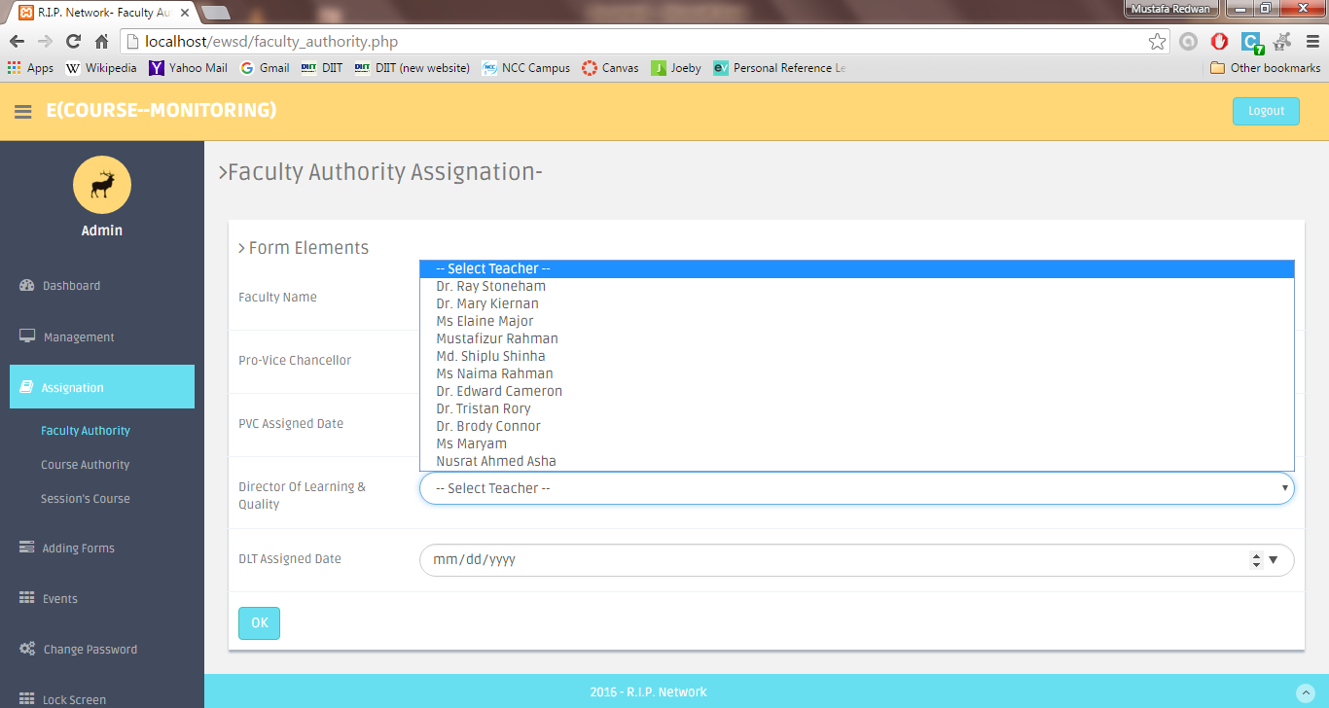

Fig 18: Director of Learning & Quality selection

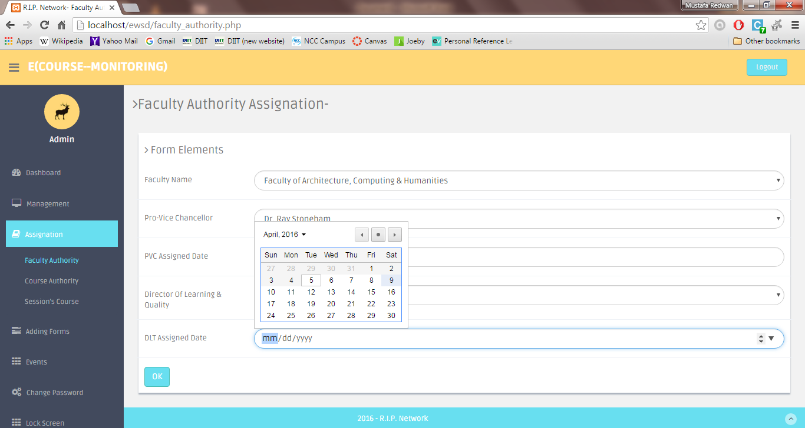

Fig 19: DLT Assigned Date – Must be today’s date or previous date.

**Course Authority:**

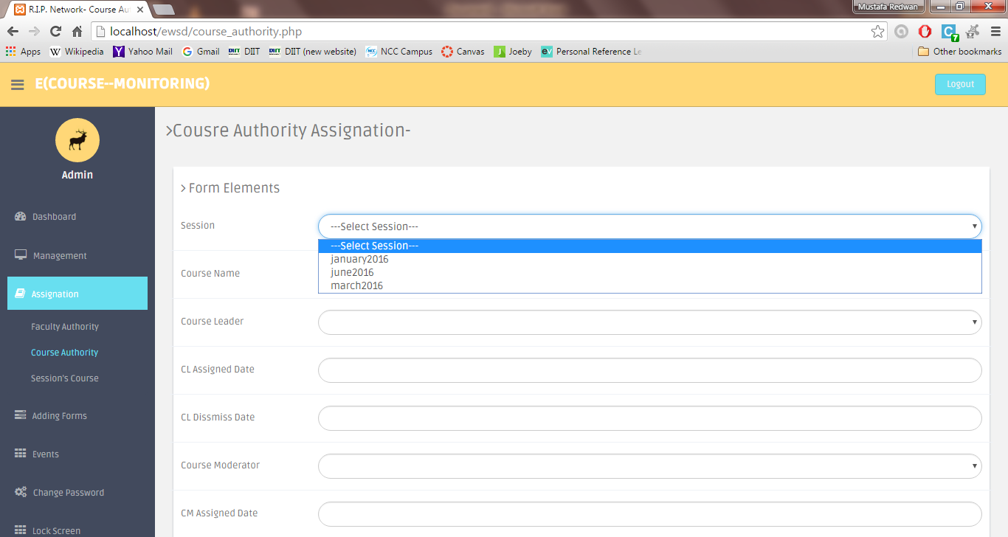

Fig 20: Session Selection

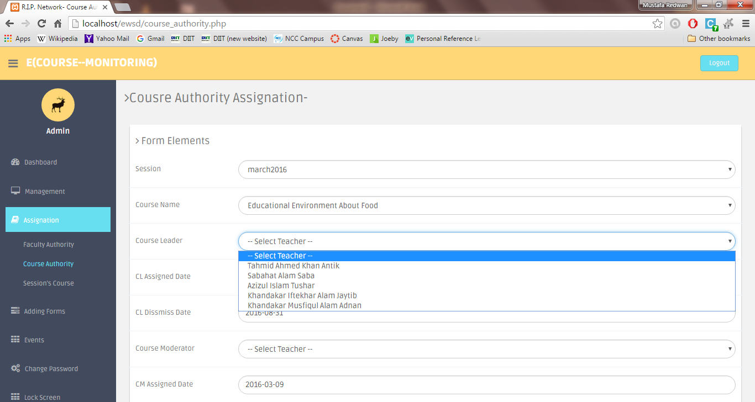

Fig 21: Course leader Selection

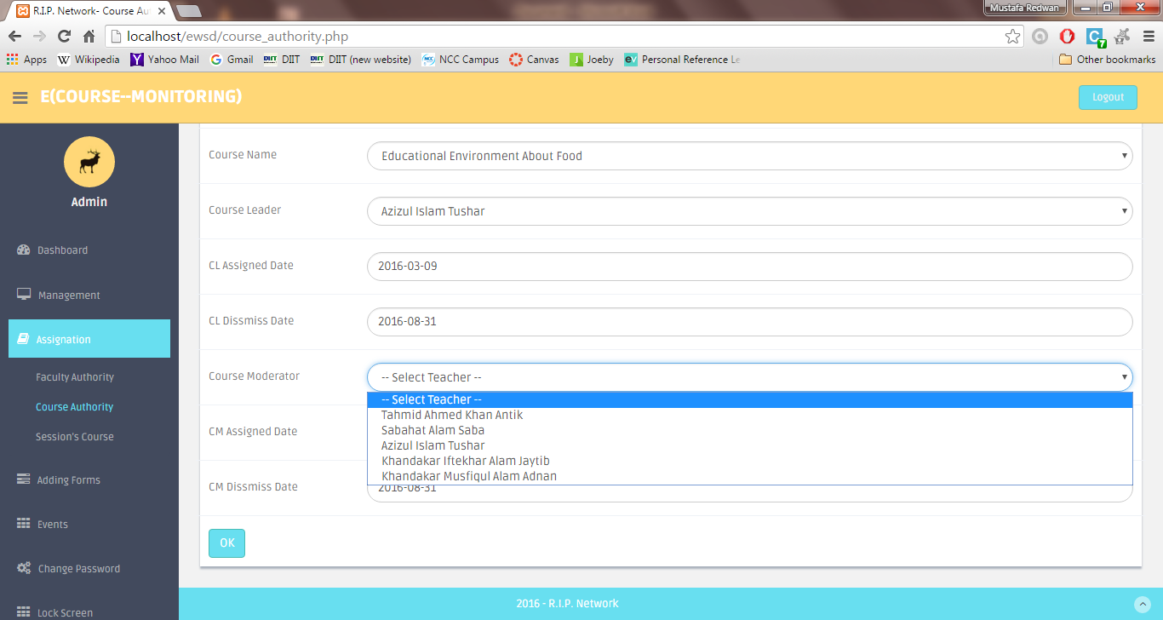

Fig 22: Course Moderator Selection

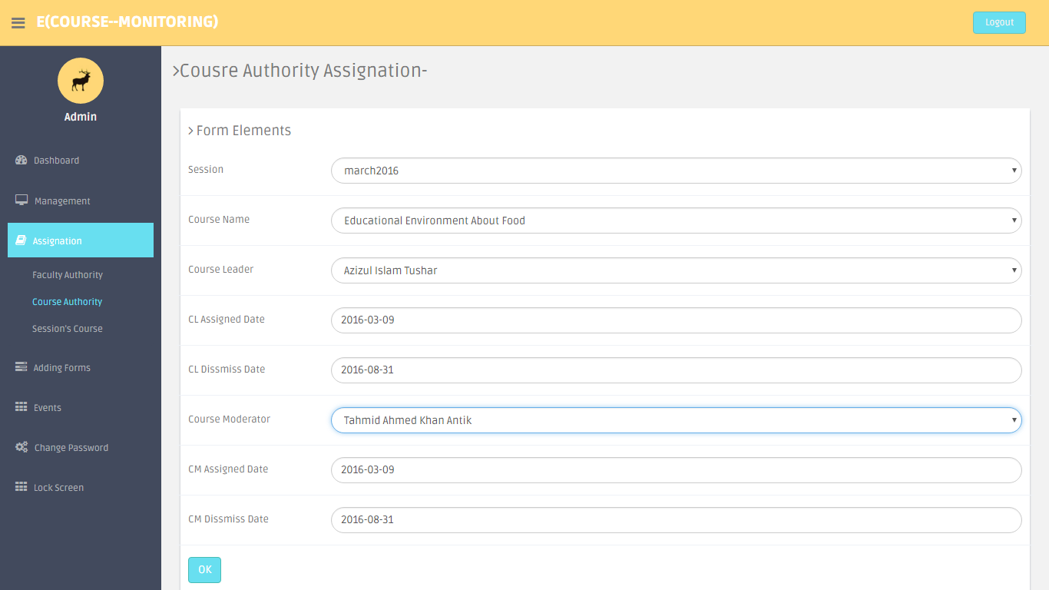

Fig 23: Completed form

**Session Course Assignation:**

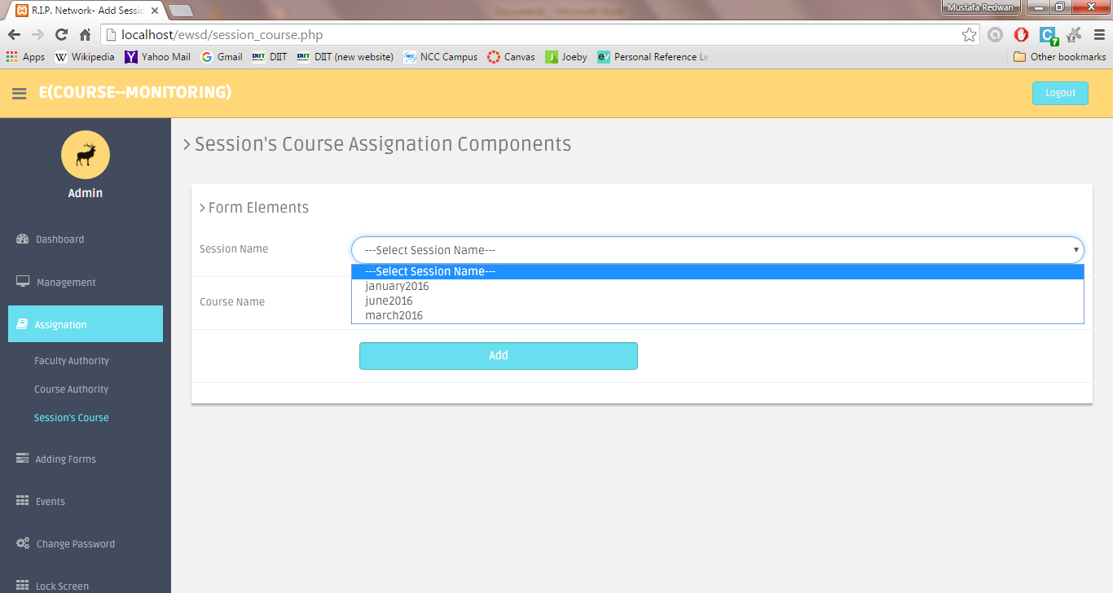

Fig 24: Session selection

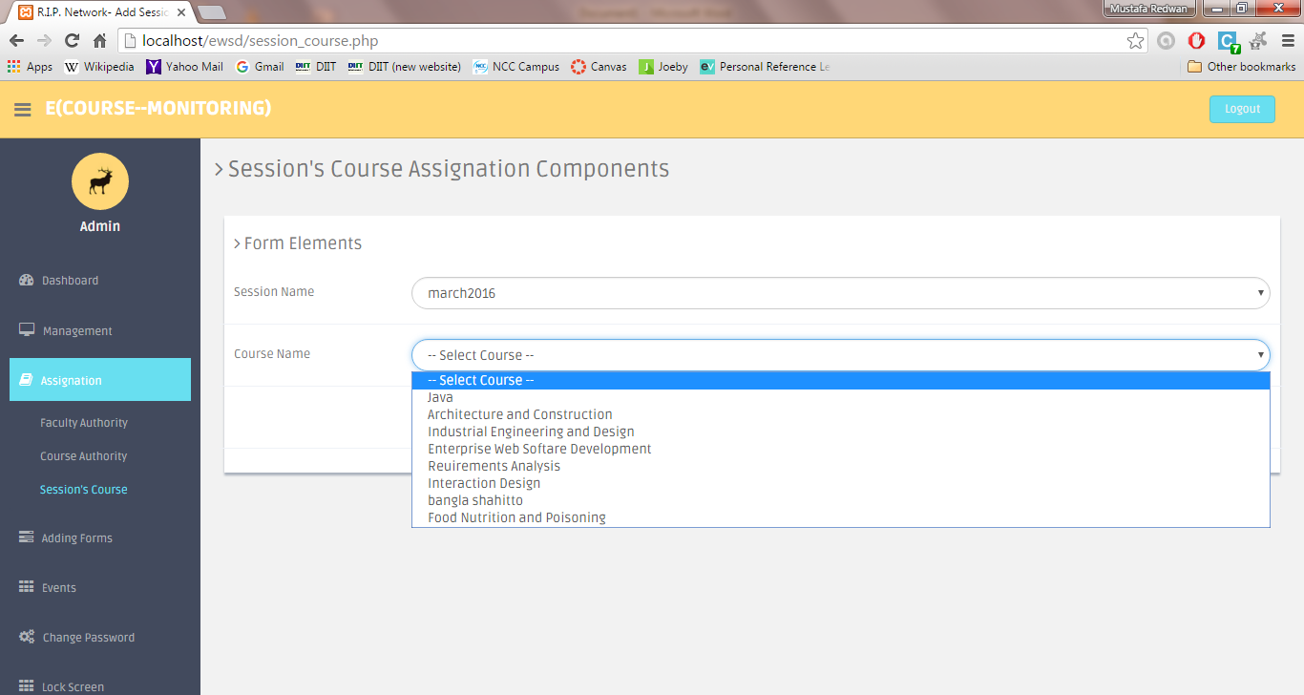

Fig 25: Course selection

**Password:**

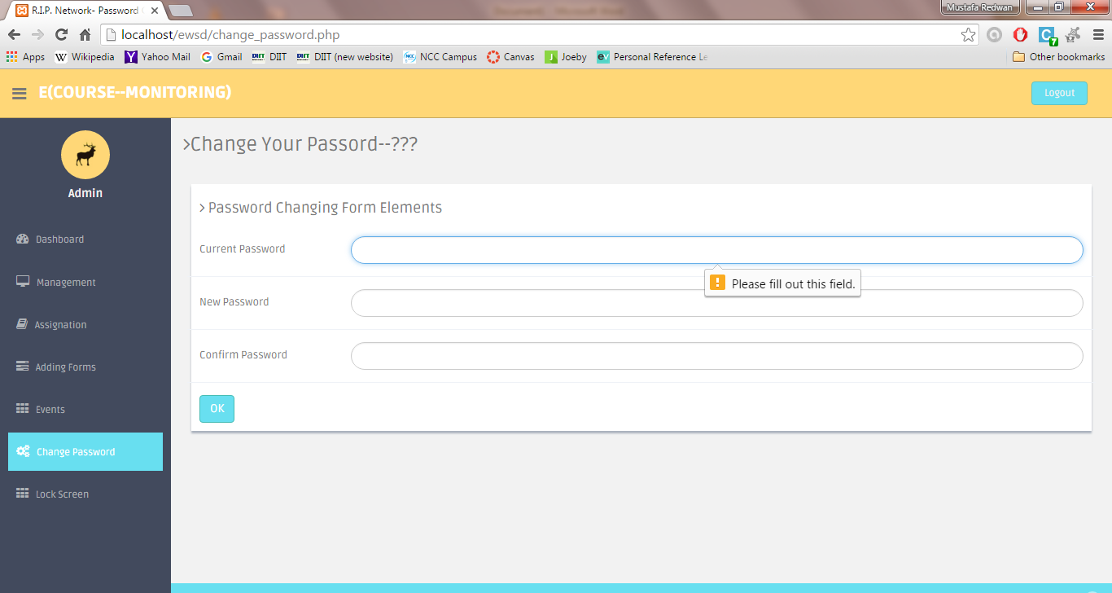

Fig 26: Current password field must be filled up

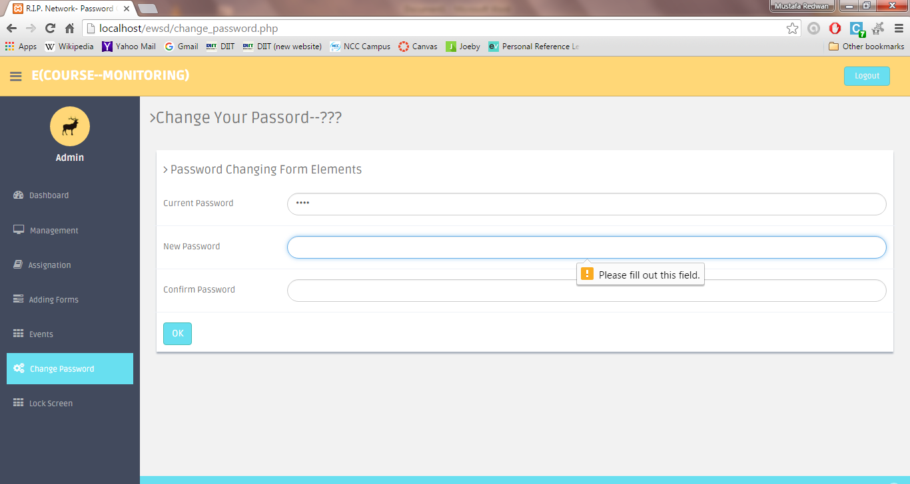

Fig 27: New & Confirm password must be filled up

**Create CMR:**

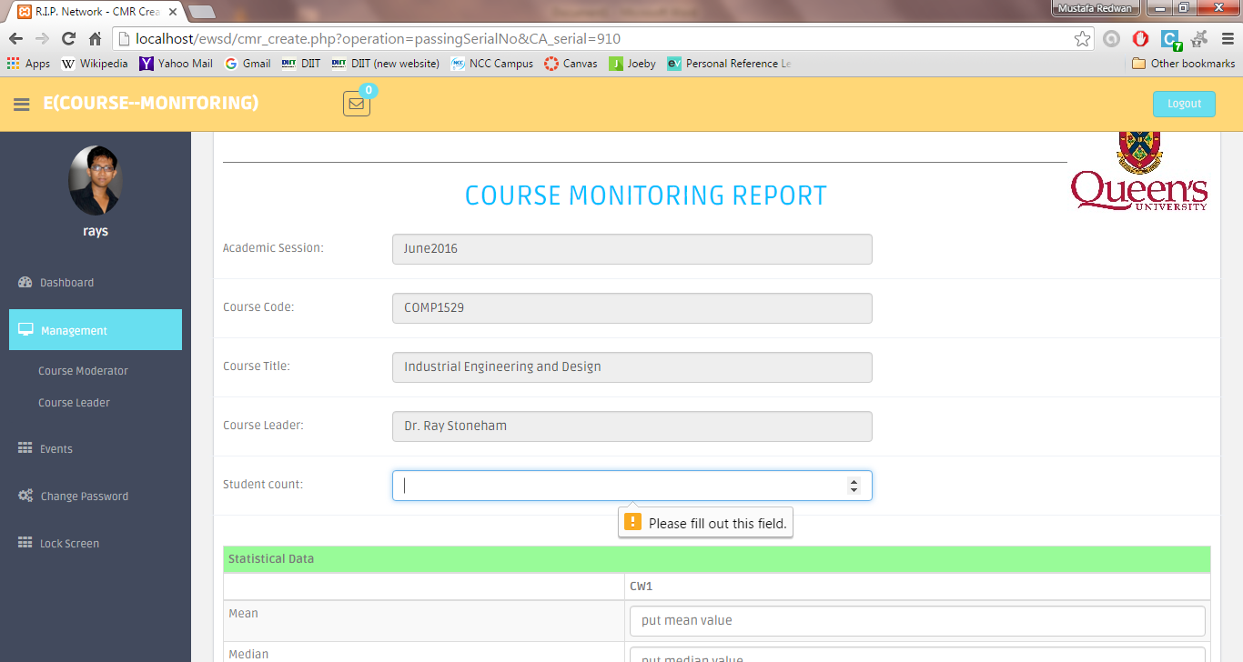

Fig 28: Student count must be filled up

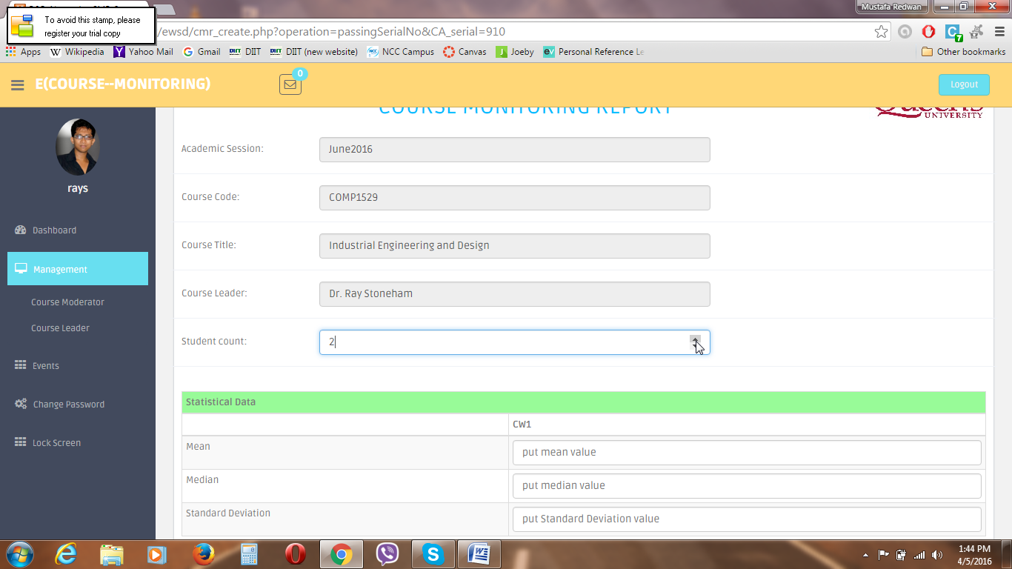

Fig 29: Entering Student count values by clicking on arrows as shown